

OPERATING SYSTEM

Lab Manual

[ Summer 2019__]

|  |  |
| --- | --- |
| Student Name:Khalid Ahmed |  |
| Student Id: 12423 |  |
|  |  |

|  |  |
| --- | --- |
|  |  |
| Instructor: *Dr. Noman Islam* |  |

**LIST OF EXPERIMENTS**

|  |  |  |  |
| --- | --- | --- | --- |
| **S. No** |  | **Experiment** |  |
| **1** |  | To study and implement socket programming in Java |  |
| **2** |  | To study and implement file I/O in Java |  |
| **3** |  | To study and implement multi-threading in Java |  |
| **4** |  | To study and execute basic Linux commands on a terminal |  |
| **5** |  | To study and execute system administration commands on a terminal |  |
| **6** |  | To study and implement shell programming in Linux |  |
| **7** |  | To study and implement information security techniques in Linux |  |
| **8** |  | To study and implement concurrency control techniques in Java |  |
| **9** |  | To study and implement process scheduling algorithms in Java |  |
| **10** |  | To study and implement file allocation techniques in Java |  |
| **11** |  | To study and implement page replacement algorithms in Java |  |
| **12** |  | To study and implement disk scheduling algorithm in Java |  |

**Lab 1**

**To study and implement socket programming in Java**

Sockets provide the communication mechanism between two computers using Transmission Control Protocol (TCP) or User Datagram Protocol (UDP). This lab will demonstrate how to implement TCP sockets using Java. Before starting the lab, download and install Java and Eclipse IDE by following the instructions below:

1. Download and Install Java Development Kit (JDK)’s latest version
2. Download ‘Eclipse’ on your computer
3. Go to Eclipse folder and Run eclipse.exe file
4. The Eclipse environment will start. Now perform the lab tasks.

**Lab Tasks:**

1. **Find the IP address of a local host using java program. Use the InetAddress class.**

**Code:**

import java.net.InetAddress;

public class IpAddress {

public static void main(String[] args) {

// TODO code application logic here

try{

InetAddress ip=InetAddress.getByName("IP Address");

System.out.println("Host Name: "+ip.getHostName());

System.out.println("IP Address: "+ip.getHostAddress());

}catch(Exception e){System.out.println(e);}

1. **Write a small port scanner application. The program usage is as follows:**

E:\ >java PortScanner 132 137

Port not in use : 132

Port not in use : 133

Port not in use : 134

Port in use : 135

Port not in use : 136

Port not in use : 137

**Code:**

import java.net.*;

public class SocketClientExample

{

public static void main(String args[])

{

int startPortRange=0;

int stopPortRange=65365;

for(int i=startPortRange; i <=stopPortRange; i++)

{

try

{

Socket ServerSok = new Socket("localhost",i);

System.out.println("Port in use: " + i );

ServerSok.close();

}

catch (Exception e)

{

System.out.println("Port not in use: " + i );

}

}

}

}

1. **Write a small server that accepts socket connection on port 2020. Develop a client application that connects to the server.**
   1. Using BufferedOutputStream, write to the server “Hello”
   2. The server should respond with the word Hello

**Code:**

Server Side Programming:

import java.net.ServerSocket;

import java.net.Socket;

public class serverexam {

public static void main(String args[])

{

try

{

ServerSocket ss = new ServerSocket(1080);

System.out.println("Listening...");

Socket s = ss.accept();

System.out.println("Client arrives...");

}

catch (Exception e)

{

}

}

}

**Client Programming:**

import java.io.IOException;

import java.net.Socket;

public class Clientexam {

public static void main(String[] args) throws IOException {

try{

Socket s = new Socket("192.168.119.94", 1080);

}

catch(Exception ex)

{

}

}

}

1. **Modify the Task 3 to develop an echo server**

**Code:**

import java.io.DataInputStream;

import java.io.DataOutputStream;

import java.net.ServerSocket;

import java.io.IOException;

import java.net.InetAddress;

import java.net.Socket;

import java.net.UnknownHostException;

public class serverexam {

public static void main(String args[])

{

try

{

ServerSocket ss = new ServerSocket(1080);

System.out.println("Listening...");

Socket s = ss.accept();

System.out.println("Client arrives...");

DataOutputStream dos = new DataOutputStream(s.getOutputStream());

DataInputStream dis = new DataInputStream(s.getInputStream());

System.out.println(dis.readUTF());

dos.writeUTF("Wsalam");

s.close();

ss.close();

}

catch (Exception e)

{

}

}

}

import java.io.DataInputStream;

import java.io.DataOutputStream;

import java.io.IOException;

import java.net.Socket;

public class Clientexam {

public static void main(String[] args) throws IOException {

try{

Socket s = new Socket("192.168.119.94", 1080);

DataOutputStream dos = new DataOutputStream(s.getOutputStream());

DataInputStream dis = new DataInputStream(s.getInputStream());

dos.writeUTF("Wsalam");

System.out.println(dis.readUTF());

s.close();

}

catch(Exception ex){ }}}

**Lab 2**

**To study and implement File I/O in Java**

**Instructions:**

Type the following program and save.

//FileTest.java

import java.io.*;

class FileTest

{

public void fileWrite()

{

File dstFile = new File("K:\\myOutput\\outputfile.txt");

PrintWriter out = new PrintWriter

(new BufferedWriter(new FileWriter(dstFile)));

out.print("Hello ");

out.println("world");

out.close();

}

}

//FileTestMain.java

import java.io.*;

class FileTestMain

{

public static void main(String[] args)

{

FileTest fileTest = new FileTest();

fileTest.fileWrite();

}

}

**Lab Tasks**

1. **Try to compile the class FileTest. What goes wrong? This is because opening up a file could throw an IOException, which is a checked exception. This means you have to tell Java how to deal with it, or the program won't compile**

Code:

public class ClassTest {

public void fileWrite() throws IOException

{

File dstFile = new File("outputfile.txt");

PrintWriter out = new PrintWriter

(new BufferedWriter(new FileWriter(dstFile)));

out.print("Hello ");

out.println("world");

out.close();

}

public static void main(String[] args) throws IOException

{

ClassTest fileTest = new ClassTest();

fileTest.fileWrite();

}

}

1. **Run your program again. If all went successfully, open up "My Computer", and find your FilePractice folder on your K drive. You should be able to find the file "outputfile.txt". Double click on it, and take a look. What do you see?**

Code:

import java.io.*;

class FileTest

{

public void fileWrite()

{

File dstFile = new File("K:\\myOutput\\outputfile.txt");

PrintWriter out = new PrintWriter

(new BufferedWriter(new FileWriter(dstFile)));

out.print("Hello ");

out.close();

}

}

//FileTestMain.java

import java.io.*;

class FileTestMain

{

public static void main(String[] args)

{

FileTest fileTest = new FileTest();

fileTest.fileWrite();

}

}

1. **Modify your program to write to the file five lines, each of which contains your name or a friend's name, followed by a space and then an age, then another space and a gpa. For example:**

Arlene 19 3.8

Bill 22 3.5

Marilyn 15 3.9

Bryan 35 1.1

Buzz 6 4.0

Code:

public class ClassTest {

/**

* @param args the command line arguments

*/

public void fileWrite() throws IOException

{

File dstFile = new File("outputfile.txt");

PrintWriter out = new PrintWriter

(new BufferedWriter(new FileWriter(dstFile)));

out.print("Arlene 19 3.8 ");

out.println("Bill 22 3.5 ");

out.print("Marilyn 15 3.9 ");

out.println("Bryan 35 1.1");

out.print("Buzz 6 4.0 ");

out.close();

}

public static void main(String[] args) throws IOException

{

ClassTest fileTest = new ClassTest();

fileTest.fileWrite();

}

}

1. **Add the following method to your FileTest class:**

public void consoleRead() throws IOException

{

BufferedReader in = new BufferedReader(new InputStreamReader(System.in));

System.out.print("What is your first name? ");

String first = in.readLine();

System.out.print("What is your last name? ");

String last = in.readLine();

System.out.println("Your name is " + last + ", " + first + ".");

}

Compile it. Add "throws" statements as necessary. Modify your main to run the consoleRead method, and recompile. Run your program. What does it do?

1. **Add the following method to FileTest.**

public void fileRead() throws IOException

{

File srcFile = new File("K:\\FilePractice\\outputfile.txt");

BufferedReader in = new BufferedReader(new FileReader(srcFile));

String text = in.readLine();

System.out.println(text);

in.close();

}

**Run the method. What do you see? Modify this method to print out the names, ages, and gpas of the five people you stored back in Task 1.**

1. In reality, you would want to be able to separate each item on each line into different variables, rather than keeping all the information on name, age, and gpa in one string. To break it up, use a StringTokenizer.

Code:

package filetestmain;

import java.io.*;

import java.util.StringTokenizer

public class Task6 {

public void fileRead() throws IOException

{

File srcFile = new File("C:\\Users\\7500.GC.000\\Documents\\NetBeansProjects\\IO\\data.txt");

BufferedReader in = new BufferedReader(new FileReader(srcFile));

String text;

while (( text = in.readLine()) != null){

StringTokenizer st = new StringTokenizer (text);

System.out.println("Name: " + st.nextToken() );

System.out.println("Age: " + st.nextToken() );

System.out.println("CGPA: " + st.nextToken() );

}

in.close();

}

}

**Lab 3**

**To study and implement multi-threading in Java**

**Instructions:**

1. A thread is an independent unit of execution.
2. In Java, the Runnable interface and Thread class of package java.lang are used for implementation of thread
3. To implement a thread, the desired class must implement the Runnable interface and provide the run() method.

public class MyThread implements Runnable {

public void run() {

//implementation of thread  
 }

}

1. The Thread class can then be used to start a thread as follows:

public class TestThread

{

public static void main( String[] args )

{

MyThread m = new MyThread();

Thread t = new Thread(m);

m.start();

}

}

**Lab Tasks:**

1. **Write a class that implements Runnable. Define a constructor that takes the name of the thread as argument. The thread upon execution will print the name of the thread in a while loop. Define and run 5 thread objects. What output do you see**?

Code:

package MultiThreading;

import java.util.logging.Level;

import java.util.logging.Logger;

public class MyThread implements Runnable {

String name;

public MyThread(String name)

{

this.name = name;

}

@Override

public void run() {

while(true)

{

try {

System.out.println("running "+ name);

Thread.sleep(1000);

} catch (InterruptedException ex) {

ex.printStackTrace();

}

}

}

}

**Test Class of Multi-Threading.**

package MultiThreading;

public class TestThread {

public static void main( String[] args )

{

for(int i =1 ; i<=5 ; i++){

MyThread m = new MyThread("Task "+i);

Thread t = new Thread(m);

t.start();

}

}

}

1. **In task 1, modify the run method to randomly sleep the thread for few milliseconds. Observe the output.**

Code:

**Random threading task.**

package MultiThreading;

import static java.lang.Math.random;

import java.util.logging.Level;

import java.util.logging.Logger;

public class MyThread implements Runnable {

String name;

public MyThread(String name)

{

this.name = name;

}

@Override

public void run() {

while(true)

{

try {

System.out.println("running "+ name);

Thread.sleep((long)(Math.random() * 10000));

} catch (InterruptedException ex) {

ex.printStackTrace();

}

}

}

}

1. **Create a multi-threaded client server application in Java.**

Code:

**Multi-Threading in Client-Server.**

package MultiThreading;

import java.io.DataInputStream;

import java.io.DataOutputStream;

import java.net.ServerSocket;

import java.io.IOException;

import java.net.InetAddress;

import java.net.Socket;

import java.net.UnknownHostException;

public class serverexam {

public static void main(String args[]) throws Exception

{

try

{

ServerSocket ss = new ServerSocket(100);

while(true){

Socket s = ss.accept();

ServerThread st = new ServerThread(s);

Thread t = new Thread(st);

t.start();

}

}

catch (Exception e)

{

}

}

}

**ServerThread.**

package MultiThreading;

import java.io.DataInputStream;

import java.io.DataOutputStream;

import java.net.ServerSocket;

import java.net.Socket;

public class ServerThread implements Runnable{

private Socket s;

public ServerThread(Socket s)

{

this.s=s;

}

public void run()

{

try

{

DataOutputStream dos = new DataOutputStream(s.getOutputStream());

DataInputStream dis = new DataInputStream(s.getInputStream());

System.out.println(dis.readUTF());

s.close();

}

catch (Exception e)

{

}

}

}

**Client Side Program.**

package MultiThreading;

import java.io.DataInputStream;

import java.io.DataOutputStream;

import java.io.IOException;

import java.net.Socket;

public class Clientexam {

public static void main(String[] args) throws IOException {

try{

Socket s = new Socket("192.168.109.56", 101);

DataOutputStream dos = new DataOutputStream(s.getOutputStream());

DataInputStream dis = new DataInputStream(s.getInputStream());

dos.writeUTF("Salam");

System.out.println(dis.readUTF());

s.close();

}

catch(Exception ex)

{

}

}

}

**Lab 4**

**To study and execute basic Linux commands on a terminal**

Linux is a Unix-like and mostly POSIX-compliant computer operating system (OS) assembled under the model of free and open-source software development and distribution. In this lab, we will work on Ubuntu, one of the flavors of Linux. For this purpose, we will use virtualization environment.

**Lab Tasks:**

1. Using ls command find out the contents of current directory

C:\Users\Naveed\Downloads\linux\linux\l1.PNG

1. What are the permissions for normal user, group and world for each file

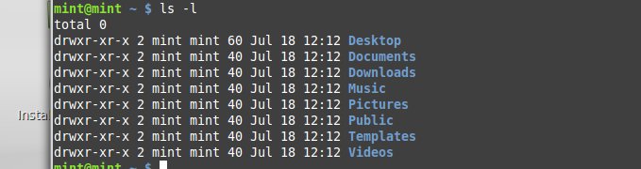

1. Find out the name of current working directory

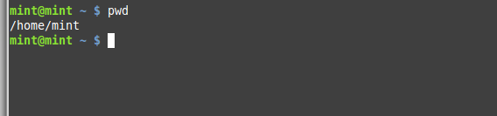

1. Create a new folder named “lab os” using the mkdir command

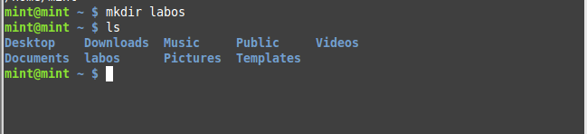

1. Switch to the directory “lab os”

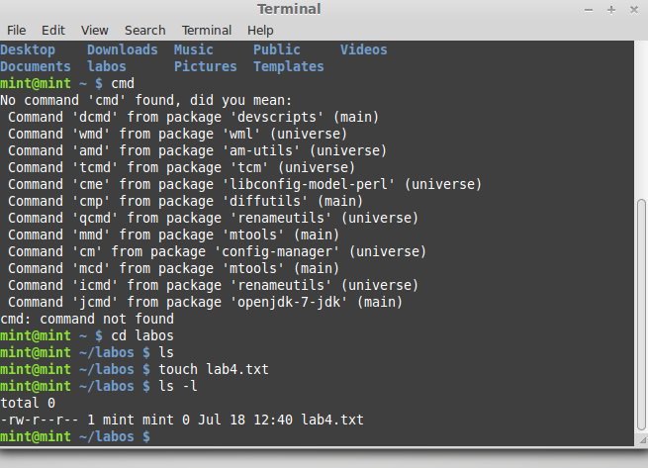

1. Create a file in the directory named “lab4.txt” using touch command



1. List down the contents of file using cat command. Try using “more” and “less” option

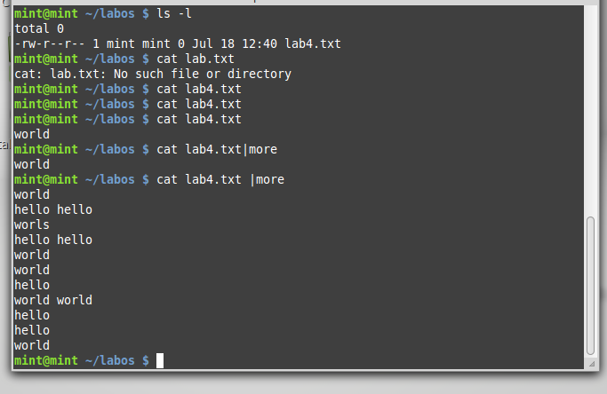

1. Find out the space consumed by directory using “du” command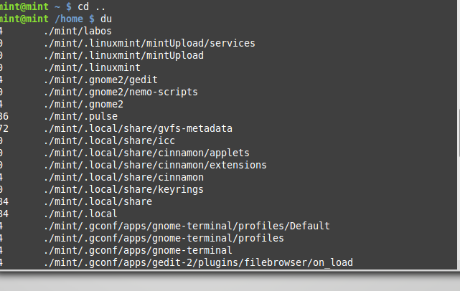
2. Copy the file to parent directory using cp command

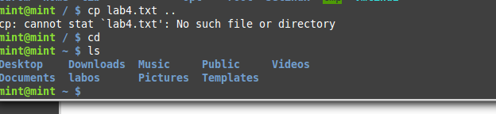

1. Remove the file using rm command

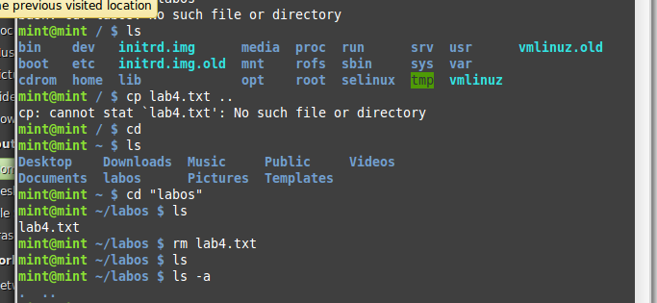

1. Remove the directory using rmdir command

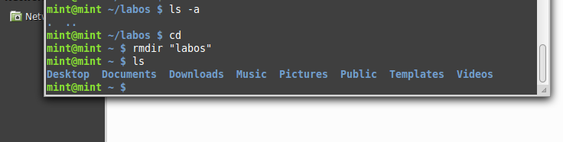

1. Check the free space on disk using df command

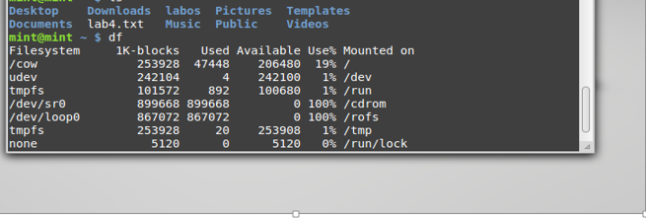

1. Change the password of the user using passwd command

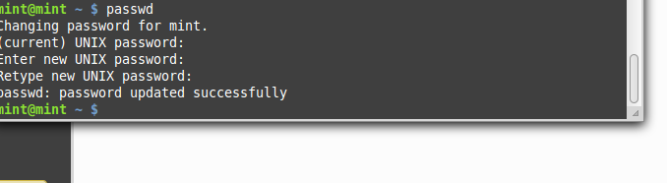

1. Switch to super user, using the command “su”

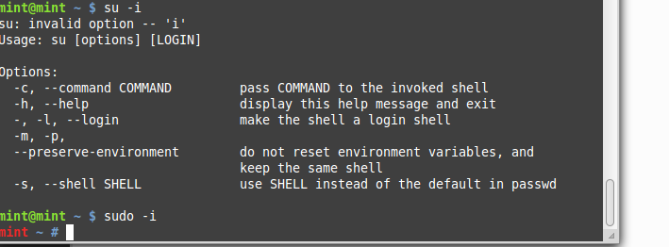

1. Using the history command, list down the commands run on the terminal window

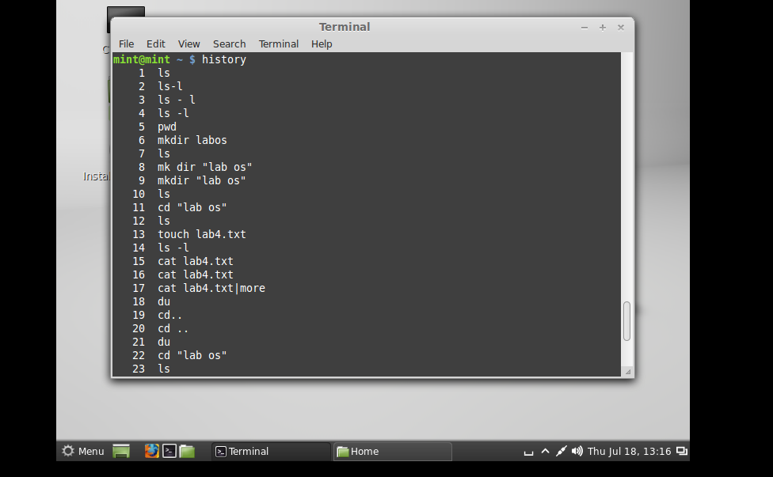

**Lab 5**

**To study and execute system administration commands on a terminal**

**Instructions:**

Linux comprises a set of commands for basic system administration. In this lab, we will study these commands.

**Lab Tasks:**

1. Using the ‘uptime' command, since how long your system is running and the number of users that are currently logged in.

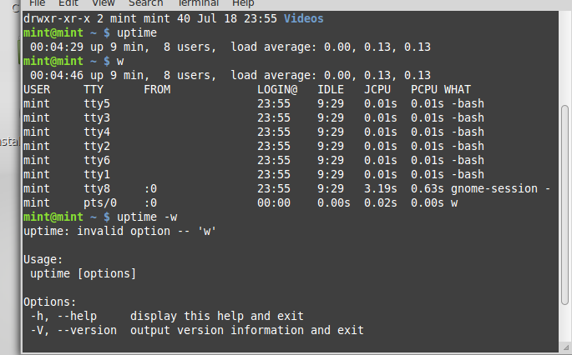

1. Using the ‘w’, display the users currently logged in and their process along-with load averages

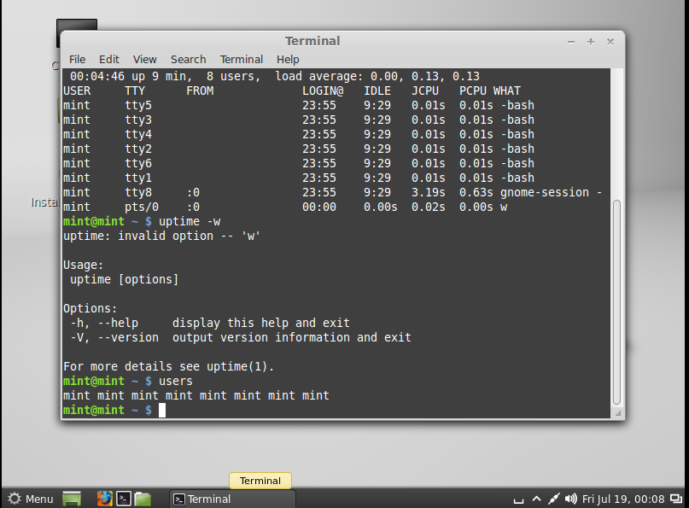

1. Using the ‘users’ command, display the currently logged in users.



1. Using the ‘top’ command, display processor activity of your system and also displays tasks managed by kernel in real-time.

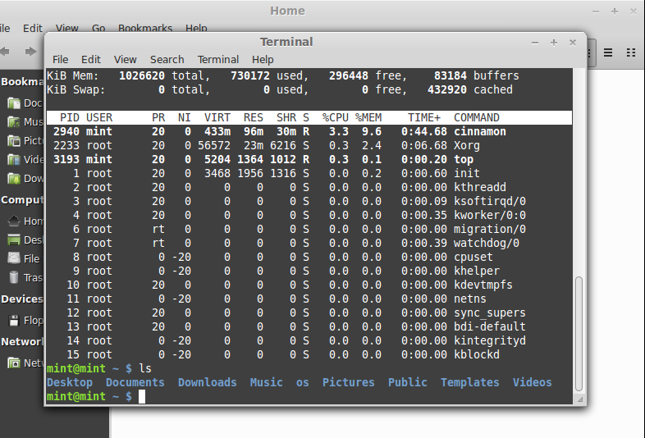

1. Using ‘tar’ command, compress your home directory in Linux.

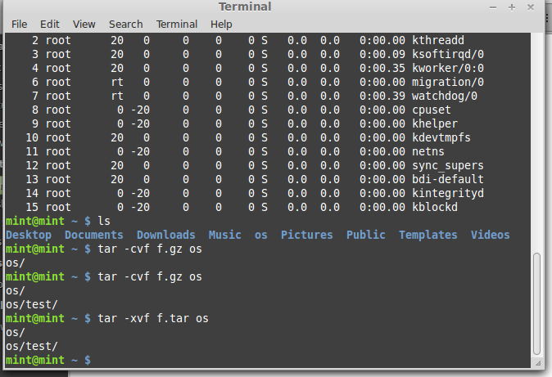

1. ‘lsof’ command to list all open files

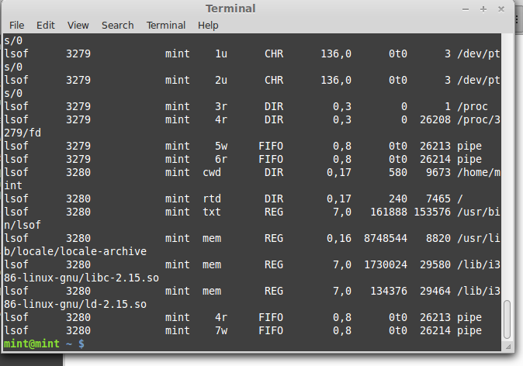

1. Using the ‘last’ command, watch activity of ‘mint’ user in the system

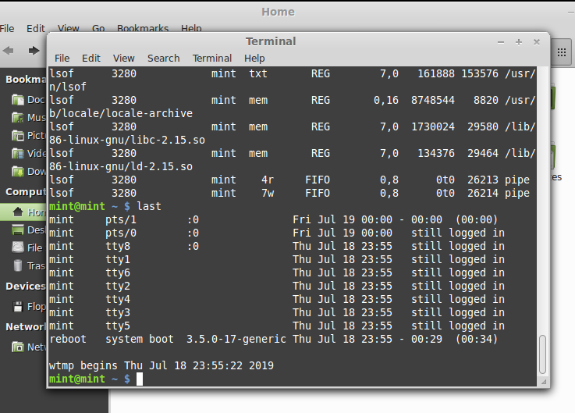

1. Using the ‘env’ command, lists all the environment variables of your system. Use ‘echo’ command to print values of $HOME and $PATH

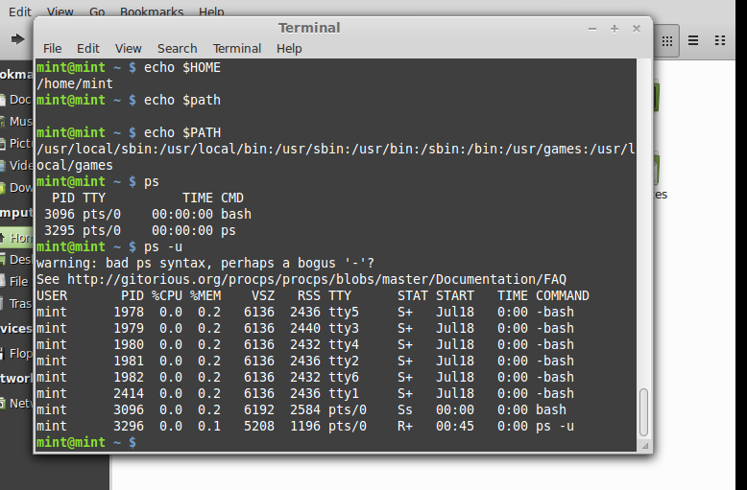

1. The ‘ps’ command displays about processes running in the system. Try option –ax, -u.



The ‘kill’ command can be used to terminate process. Using this command terminate some processes of your system

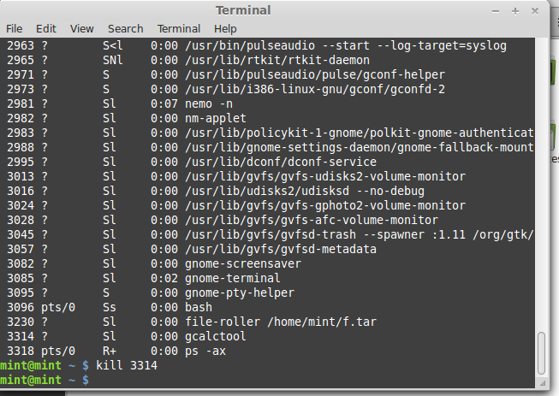

1. ‘ifconfig’ command is used to show the configuration of internet on LINUX. Use this command to find IP and MAC address of your computer

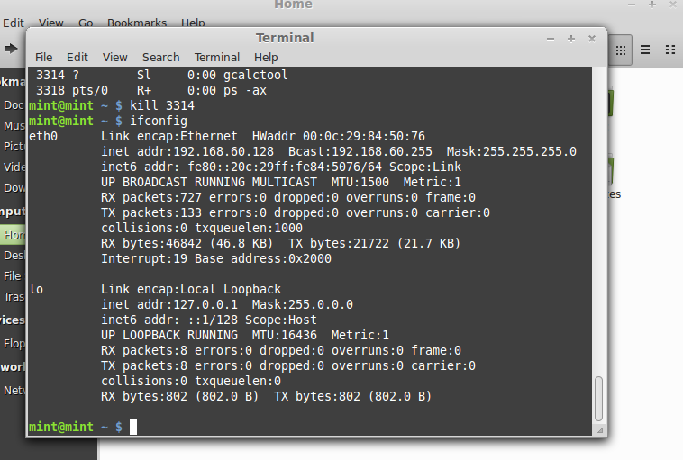

1. Using the ‘netstat’ command, show the status of your network

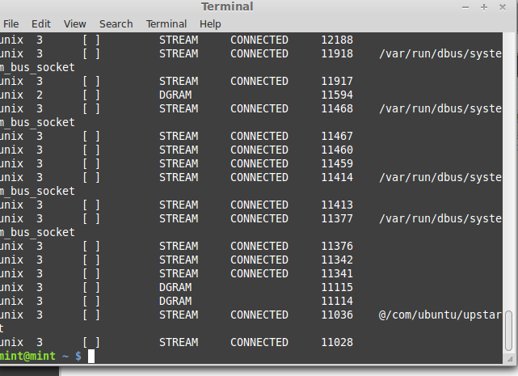

1. Using the ping command, to ping your localhost

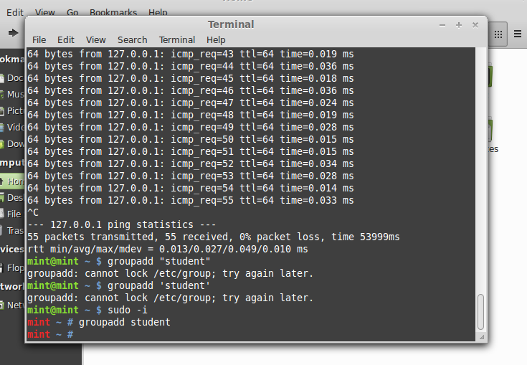

1. Create a group named ‘student’ using groupadd



1. Create a file named ‘hello.txt’

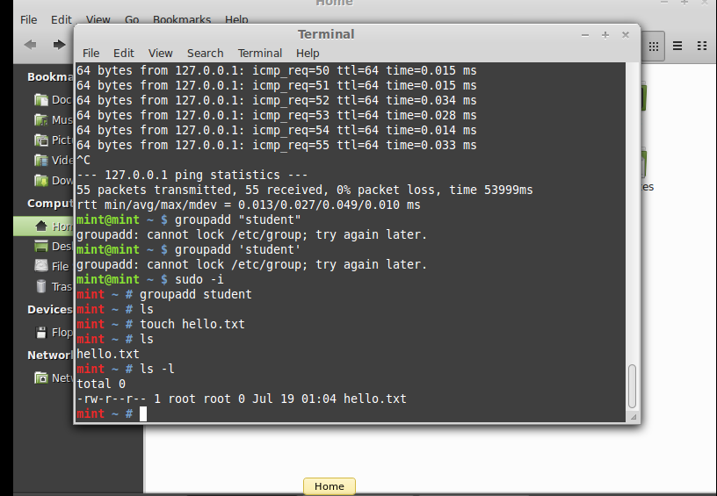

1. Using the ‘useradd’ command create a user with your name in the group student

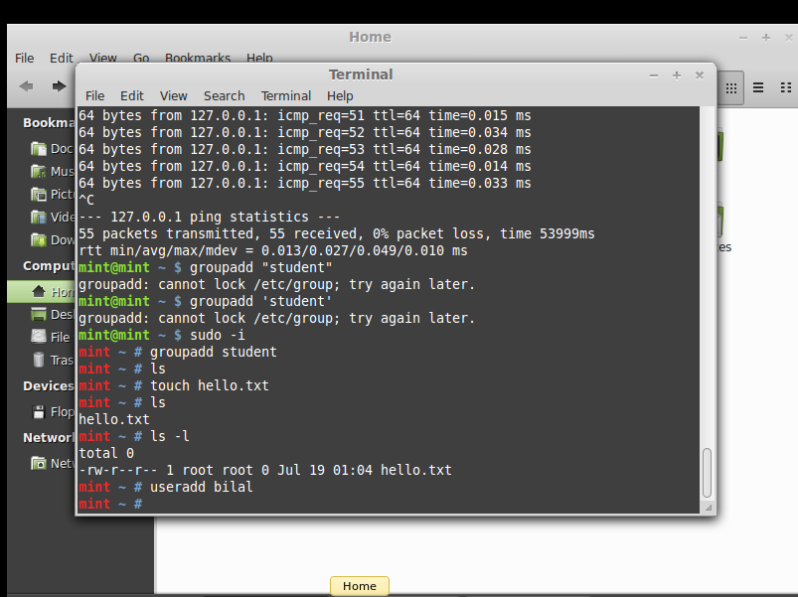

1. Change the owner of hello.txt to user you just created

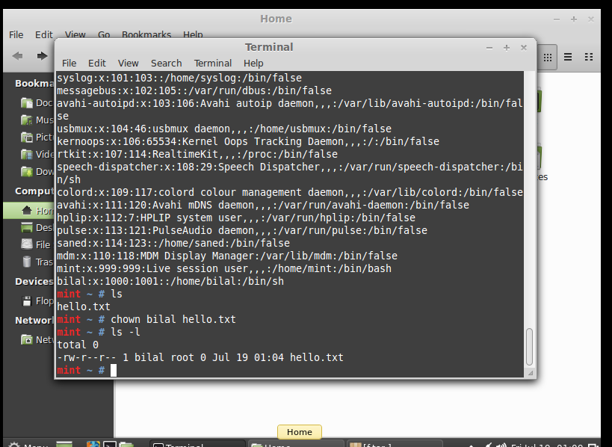

1. Change the group owner of hello.txt to group student

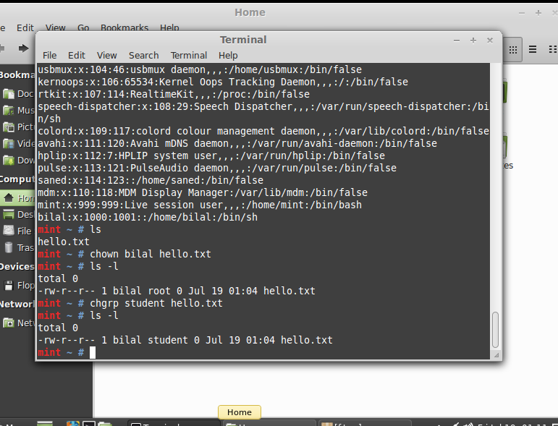

**Lab 6**

**To study and implement shell programming in Linux**

**Instructions:**

1. A shell script is a computer program designed to be run by the Unix shell, a command-line interpreter
2. The various dialects of shell scripts are considered to be scripting languages.
3. Typical operations performed by shell scripts include file manipulation, program execution, and printing text.

**Lab Tasks:**

1. Write a script that backs itself up, that is, copies itself to a file named backup.sh.   
   Hint: Use the cat command

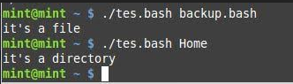

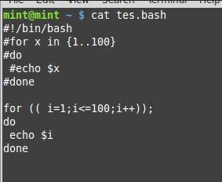

2Write a script that echoes itself to stdout, but backwards.

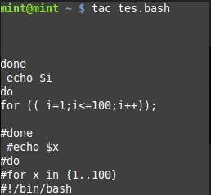

Hint: Use the tac command

1. Perform a recursive directory listing on the user's home directory and save the

information to a file.

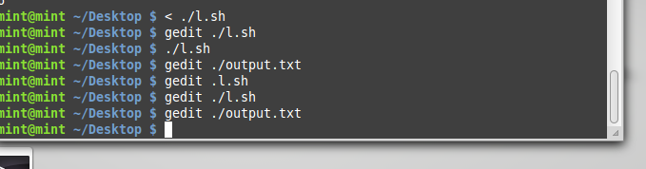

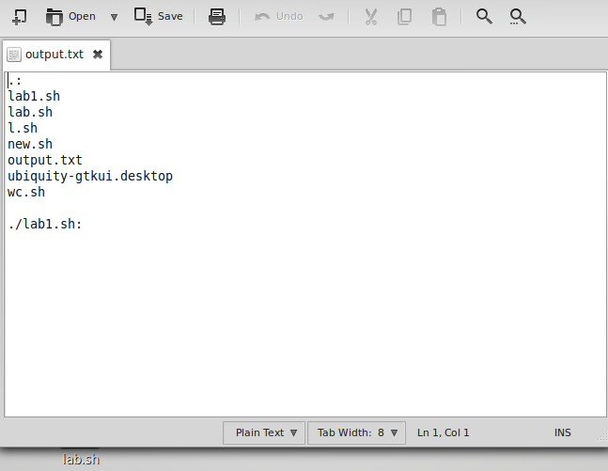

1. Write a script that reads each line of a target file, then writes the line back to stdout, but with an extra blank line following. This has the effect of double-spacing the file.

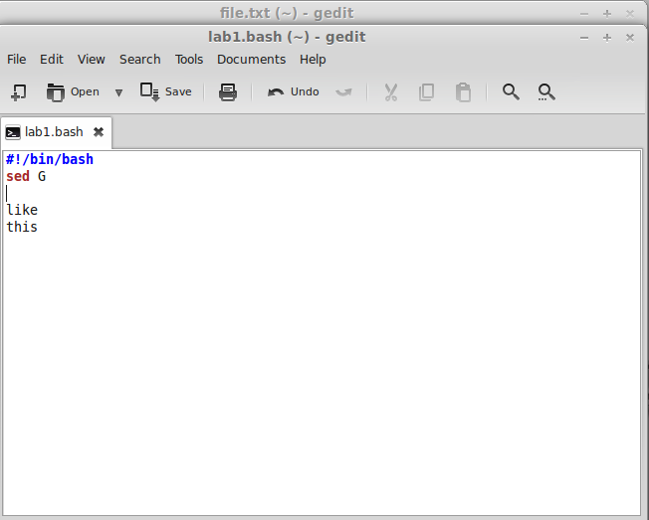

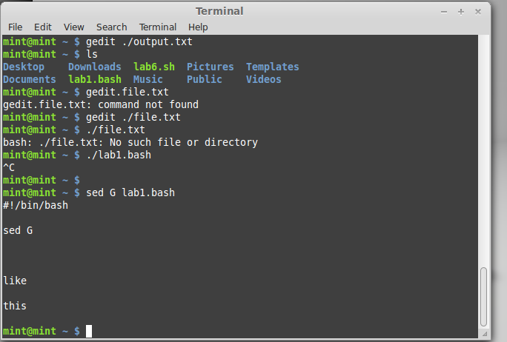

1. Write a shell script that takes a command –line argument and reports on whether it is directory, a file

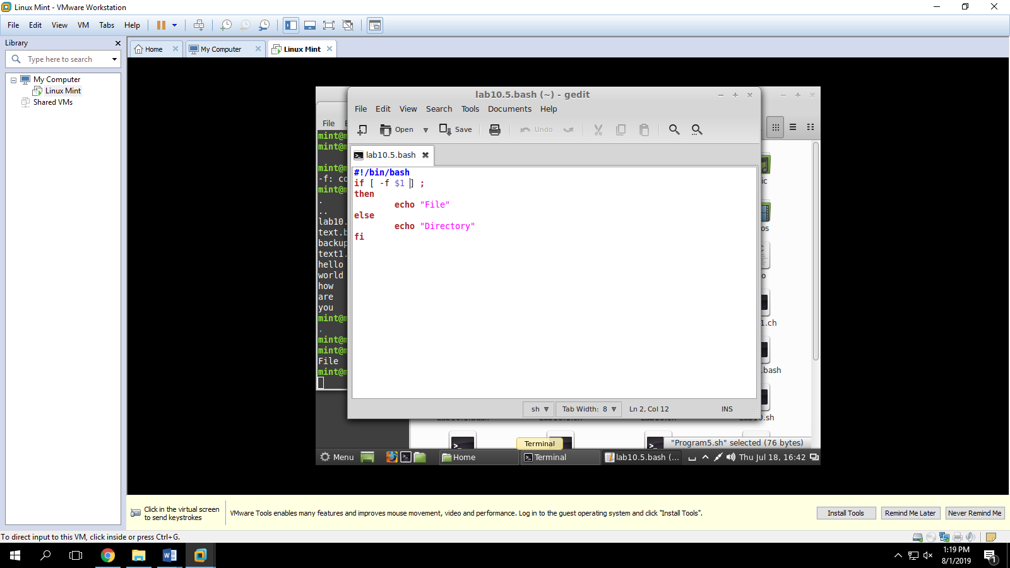

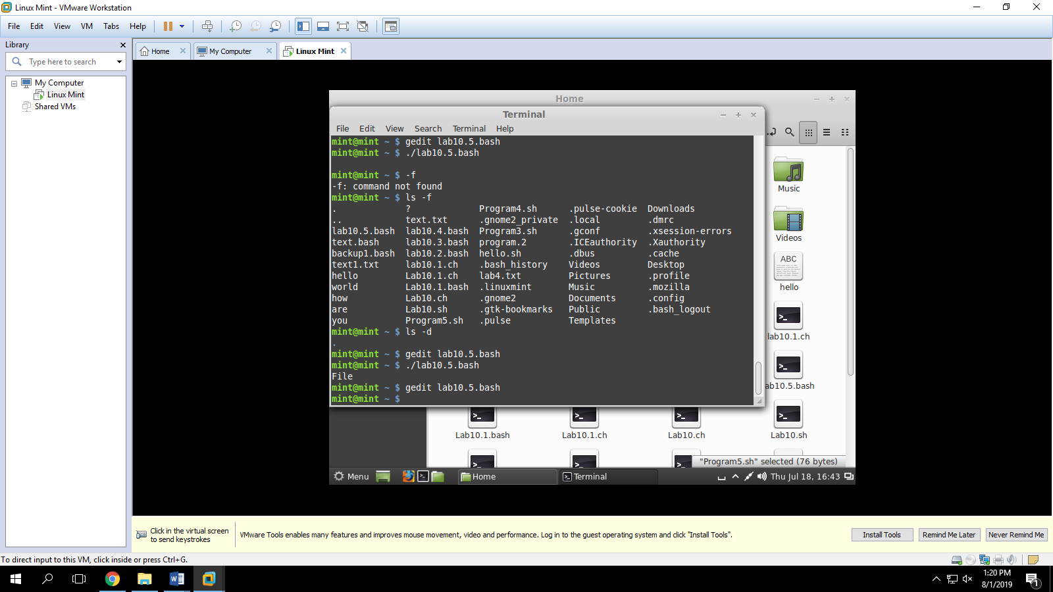

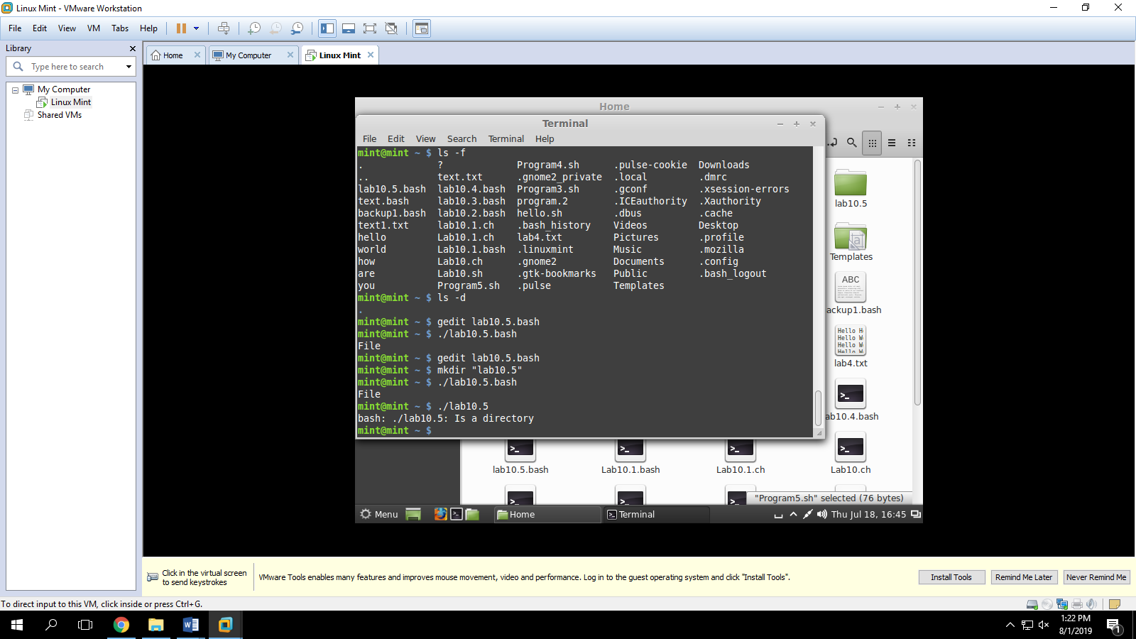

1. Write a shell script program to display list of user currently logged in.

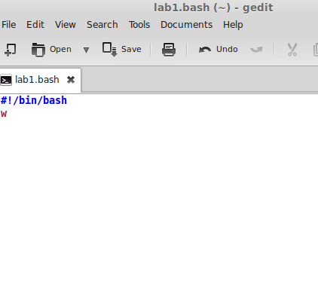

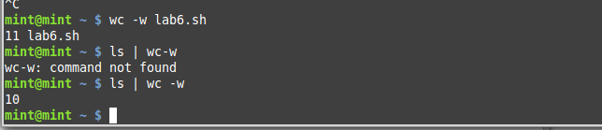

1. Shell script program to count number of files in a Directory.

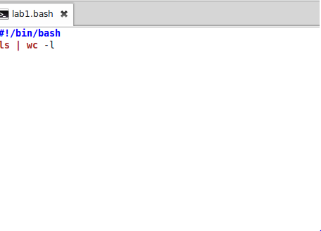

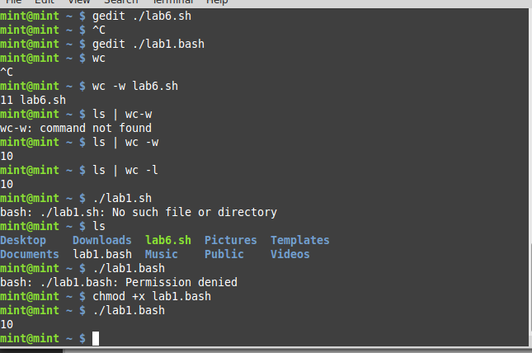

**Lab 7**

**To study and implement information security techniques in Linux**

In this lab, we will explore the basic information security tools available in Linux. There are a number of tools available in Linux. This lab only covers nmap, whois and wireshark tool

**Lab Tasks**

1. Download and install the three tools nmap, whois and wireshark tool on Linux. What command did you use to install?
2. Now run the nmap tool on <http://iqra.edu.pk>. Capture the output.
3. Provide a commentary on the output

Nmap can be used to monitor single hosts as well as vast networks that encompass hundreds of thousands of devices and multitudes of subnets

1. 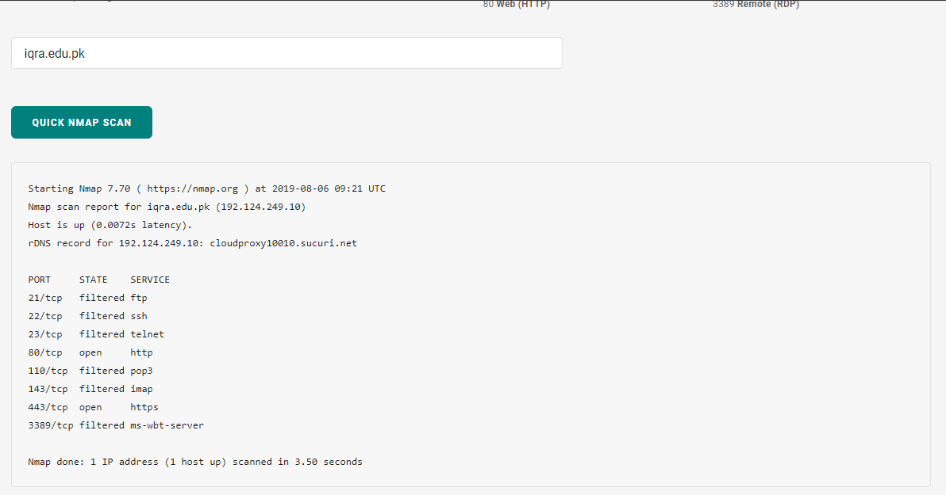Run the whois tool on <http://iqra.edu.pk>. Capture the output

Commentary:

Nmap tool is used to find the open ports on internet facing system, the result shows the open ports of the site: iqra.edu.pk

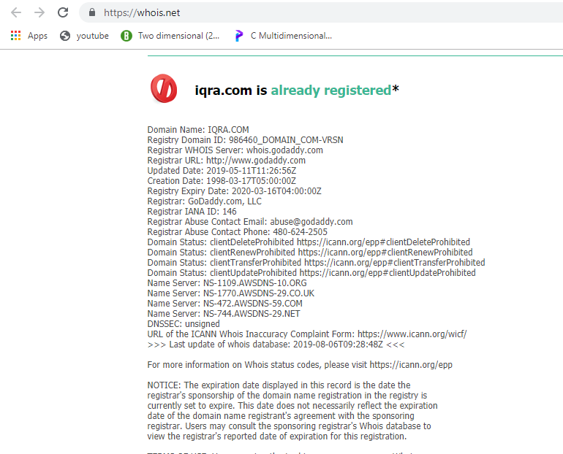

1. Provide a commentary on the output

Whois.net: shows domains, ip’s , names , servers. The result shows information of iu it’s domain name and servers.

1. With the wireshark tool capturing the interface data, browse http://iqra .edu.pk

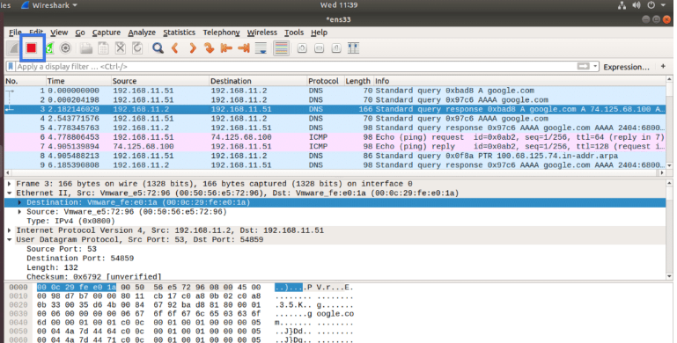

1. Capture the HTTP protocol message

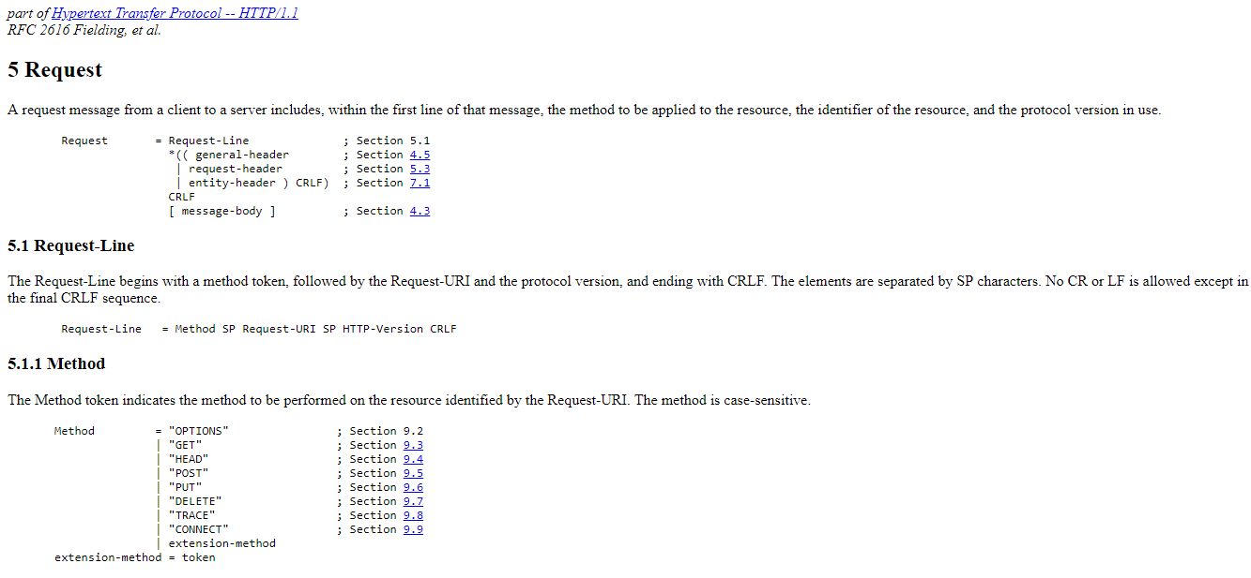

1. Provide the commentary on the above captured message

HTTP is the underlying protocol used by the World Wide Web and this protocol defines how messages are formatted and transmitted, and what actions Web servers and browsers should take in response to various common

**Lab 8**

**To study and implement concurrency control techniques in Java**

Java provides the synchronized key word for implementing concurrency control while using multi-threaded applications. In this lab, you will learn how to implement these techniques.

**Instructions:**

Create the following program in Java:

public class UnsynchronizedExample {

public static void main(String[] args) {

new PrintStringsThread("Hello ", "there.");

new PrintStringsThread("How are ", "you?");

new PrintStringsThread("Thank you ", "very much!");

}

}

public class PrintStringsThread implements Runnable {

Thread thread;

String str1, str2;

PrintStringsThread(String str1, String str2) {

this.str1 = str1;

this.str2 = str2;

thread = new Thread(this);

thread.start();

}

public void run() {

TwoStrings.print(str1, str2);

}

}

public class TwoStrings {

// This method is not synchronized

static void print(String str1, String str2) {

System.out.print(str1);

try {

Thread.sleep(500);

} catch (InterruptedException ie) {

}

System.out.println(str2);

}

}

**Lab Tasks:**

1. What output do you see? Explain the output.

Code:

package unsynchronizedexample;

/**

*

* @author 7500

*/

public class UnsynchronizedExample {

public static void main(String[] args) {

new PrintStringsThread("Hello ", "there.");

new PrintStringsThread("How are ", "you?");

new PrintStringsThread("Thank you ", "very much!");

}

}

package unsynchronizedexample;

/**

*

* @author 7500

*/

public class PrintStringsThread implements Runnable {

Thread thread;

String str1, str2;

PrintStringsThread(String str1, String str2) {

this.str1 = str1;

this.str2 = str2;

thread = new Thread(this);

thread.start();

}

public void run() {

TwoStrings.print(str1, str2);

}

}

package unsynchronizedexample;

/**

*

* @author 7500

*/

public class TwoStrings {

// This method is not synchronized

static print(String str1, String str2) {

System.out.print(str1);

try {

Thread.sleep(500);

} catch (InterruptedException ie) {

}

System.out.println(str2);

}

}

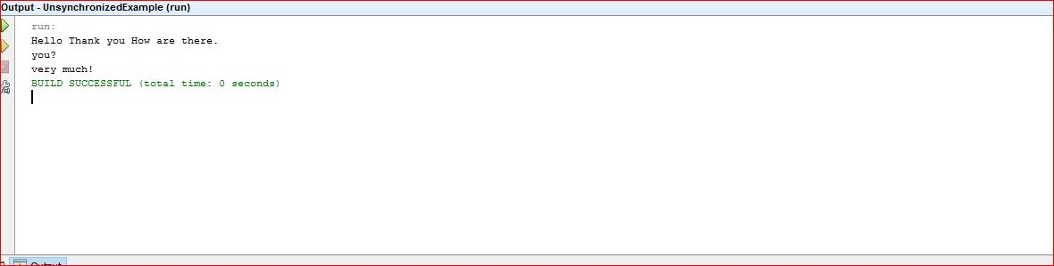

1. Now use the synchronized methods to display the desired result.

Code:

package unsynchronizedexample;

/**

*

* @author 7500

*/

public class TwoStrings {

// This method is not synchronized

static synchronized void print(String str1, String str2) {

System.out.print(str1);

try {

Thread.sleep(500);

} catch (InterruptedException ie) {

}

System.out.println(str2);

}

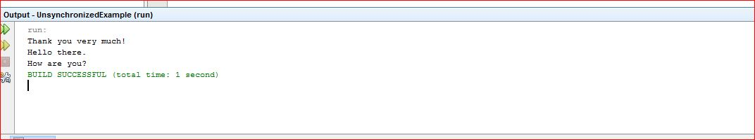

1. Now use the synchronized keyword on an object to synchronize.

Code:

package javaapplication29;

public class PrintStringsThread implements Runnable {

Thread thread;

String str1, str2;

static TwoStrings ts = new TwoStrings();

PrintStringsThread(String str1, String str2) {

this.str1 = str1;

this.str2 = str2;

thread = new Thread(this);

thread.start();

}

public void run() {

//TwoStrings.print(str1, str2);

ts.print(str1,str2);

}

}

package javaapplication29;

/**

*

* @author 7500

*/

public class TwoStrings {

static void print(String str1, String str2) {

synchronized(this){

System.out.print(str1);

try {

Thread.sleep(500);

} catch (InterruptedException ie) {

}

System.out.println(str2);

}

}

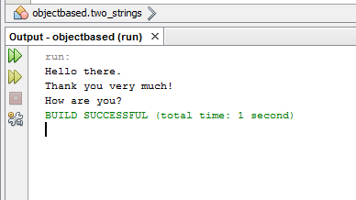

**Lab 9**

**To study and implement process scheduling algorithms in Java**

**Instructions:**

In this lab, we will implement different CPU scheduling techniques.

**Lab Tasks**

1. **Shortest Job First:** The number of processes and burst time is input from the user. The program should then print total access time, burst time and wait time for every process. Also print the average wait time.

Hint: Sort the element based on their burst time

Code:

package processscheduling;

import java.util.*;

public class ProcessScheduling {

public long id;

public long pri;

public long burstTime;

public long accessTime;

public long waitTime;

ProcessScheduling(int id, int Btime, int pri){

this.id=id;

this.burstTime=Btime;

this.pri=pri;

}

@Override

public String toString(){

return "Process :"+ id + " Burst Time : "+ this.burstTime + " Priority " + pri + " Waiting Time "+ waitTime;

}

/**

* @param args the command line arguments

*/

public static void main(String[] args) {

ArrayList<ProcessScheduling> al=new ArrayList<ProcessScheduling>();

System.out.println("Enter The Number of Processes : ");

Scanner scan = new Scanner(System.in);

int n = scan.nextInt();

for(int i=0;i<n;i++){

System.out.println("Enter The Burst Time and Priority : ");

ProcessScheduling p=new ProcessScheduling(i,scan.nextInt(), scan.nextInt());

al.add(p);

}

sjf(al);

System.out.println(al);

}

public static void sjf(ArrayList al){

int s=0;

int currentTime=0;

while(al.size()!=0){

for(int i=1;i<al.size();i++){

ProcessScheduling p =(ProcessScheduling)al.get(i);

ProcessScheduling shortest=(ProcessScheduling)al.get(s);

if(p.burstTime<shortest.burstTime){

s=i;

}

}

ProcessScheduling shortest = (ProcessScheduling)al.get(s);

shortest.waitTime=currentTime;

System.out.println(shortest);

currentTime+=shortest.burstTime;

al.remove(s);

}

}

}

1. Simulate the First Come First Serve and Priority scheduling algorithm

Code

package lab7;

import java.util.Scanner;

/**

*

* @author 7500

*/

public class Process {

public int id;

public int bursttime ;

public int waittime;

public int priority;

public Process(int id, int bursttime, int priority){

this.id =id;

this.bursttime =bursttime;

this.priority =priority;

}

@Override

public String toString(){

return "Process : " + id + " Burst Time : " +this.bursttime + " Priority : " + this.priority + " Wait Time : " + this.waittime;

}

}